DAD 220

Ashley Turnbull

Athena Mestas

14 February 2024

**Goal**: Analyze sales data by state to determine where the company has the largest customer base.

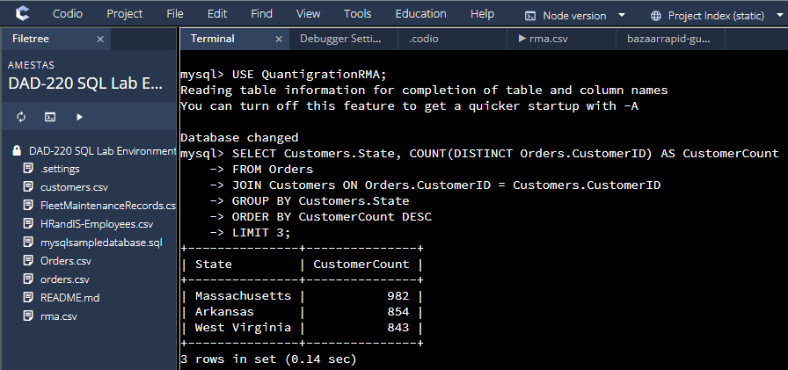

Code used: USE QuantigrationRMA; SELECT Customers.State, COUNT(DISTINCT Orders.CustomerID) AS CustomerCount FROM Orders JOIN Customers ON Orders.CustomerID = Customers.CustomerID GROUP BY Customers.State ORDER BY CustomerCount DESC LIMIT 3;

**Goal**: Analyze the data to determine the top three products sold in the United States.

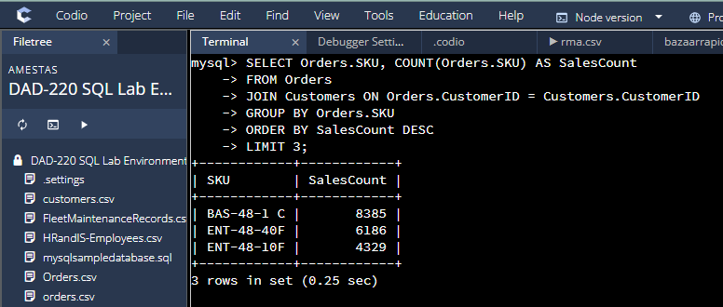

Code used: SELECT Orders.SKU, COUNT(Orders.SKU) AS SalesCount FROM Orders JOIN Customers ON Orders.CustomerID = Customers.CustomerID GROUP BY Orders.SKU ORDER BY SalesCount DESC LIMIT 3;

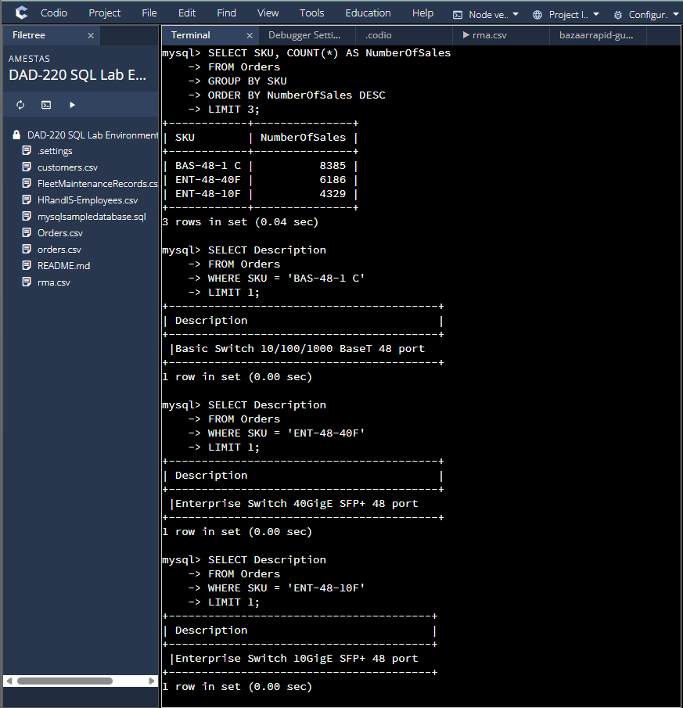

Code used: SELECT SKU, COUNT(*) AS NumberOfSales FROM Orders GROUP BY SKU ORDER BY NumberOfSales DESC LIMIT 3; SELECT Description FROM Orders WHERE SKU = 'BAS-48-1 C' LIMIT 1; SELECT Description FROM Orders WHERE SKU = 'ENT-48-40F' LIMIT 1; SELECT Description FROM Orders WHERE SKU = 'ENT-48-10F' LIMIT 1;

**Goal**: Analyze the data to determine the top three products sold in the southeastern region of the United States.

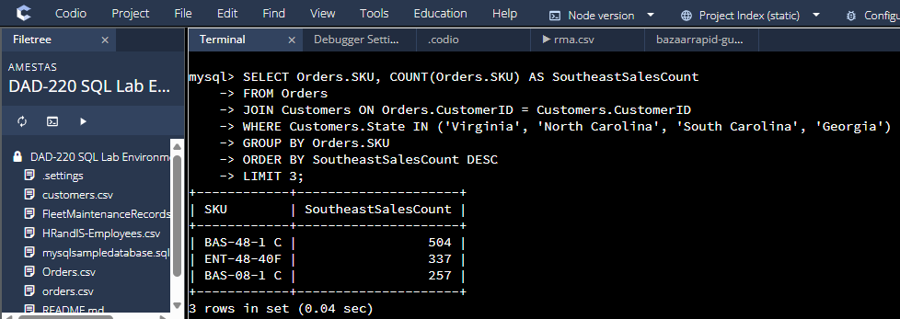

Code used: SELECT Orders.SKU, COUNT(Orders.SKU) AS SoutheastSalesCount FROM Orders JOIN Customers ON Orders.CustomerID = Customers.CustomerID WHERE Customers.State IN (’Virginia’, ’North Carolina’, ’South Carolina’, ’Georgia’) GROUP BY Orders.SKU ORDER BY SoutheastSalesCount DESC LIMIT 3;

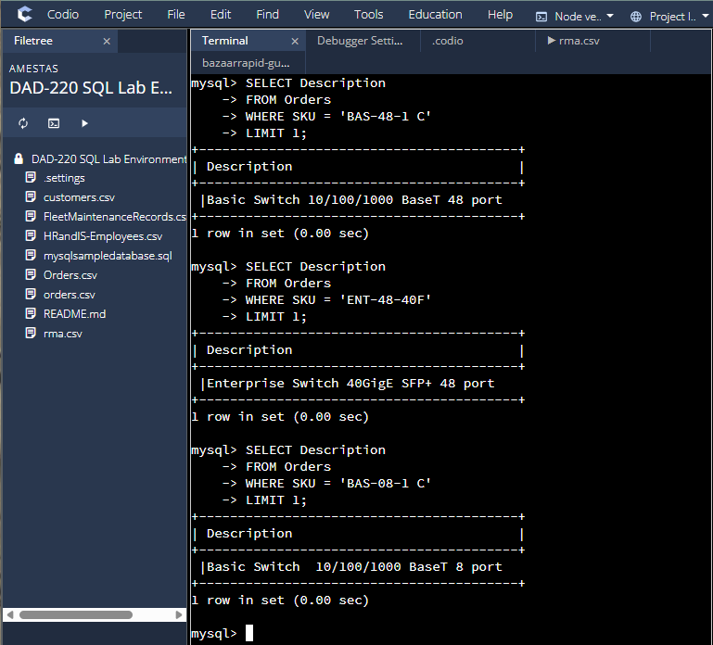

Code used: SELECT Description FROM Orders WHERE SKU = 'BAS-48-1 C' LIMIT 1; SELECT Description FROM Orders WHERE SKU = 'ENT-48-40F' LIMIT 1; SELECT Description FROM Orders WHERE SKU = 'BAS-08-1 C' LIMIT 1;

**Goal**: Analyze the data to determine the top three products returned in the United States.

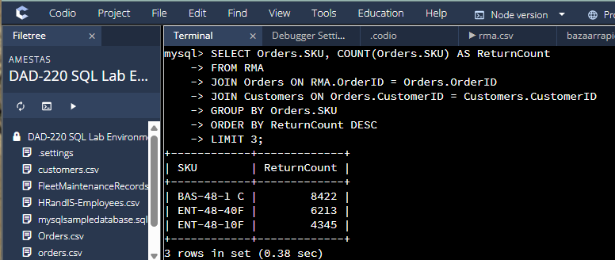

Code used: SELECT Orders.SKU, COUNT(Orders.SKU) AS ReturnCount FROM RMA JOIN Orders ON RMA.OrderID = Orders.OrderID JOIN Customers ON Orders.CustomerID = Customers.CustomerID GROUP BY Orders.SKU ORDER BY ReturnCount DESC LIMIT 3;

**Goal**: Analyze the data to determine the top three products returned in the northwestern region of the United States.

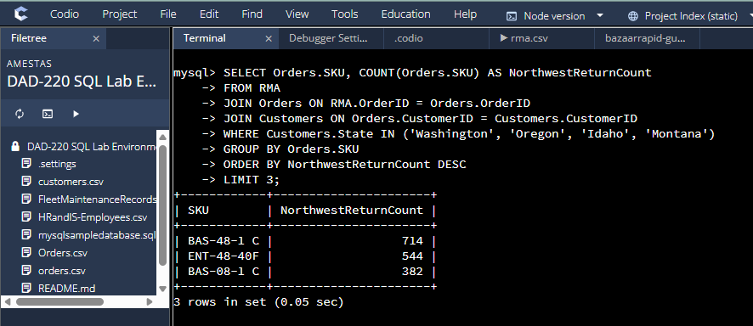

Code used: SELECT Orders.SKU, COUNT(Orders.SKU) AS NorthwestReturnCount FROM RMA JOIN Orders ON RMA.OrderID = Orders.OrderID JOIN Customers ON Orders.CustomerID = Customers.CustomerID WHERE Customers.State IN ('Washington', 'Oregon', 'Idaho', 'Montana') GROUP BY Orders.SKU ORDER BY NorthwestReturnCount DESC LIMIT 3;

**Goal**: Write a report to the Quantigration product manager that explains your findings in a way nontechnical stakeholders can digest and use.

Dear Quantigration Manager,

The analysis conducted revealed numerous findings that communicate sales data by region and returns data by region, as well as subfields including largest customer base state-wise, top three most popular products nationwide, and top three most returned products nationwide. The company’s largest customer base resides in Massachusetts, with a customer count of 982; following Massachusetts, Arkansas and West Virginia rank second and third – with a customer count of 854 and 843, respectively. The data collected from the comparison of states could suggest opportunities for marketing and customer engagement efforts – either to strengthen consumer activity in these states, or, to concentrate the company’s outreach to other states. Regarding the most popular products sold in the United States, the top three include: the Basic Switch 10/100/1000 BaseT 48 port (the SKU for this product is BAS-48-1 C) with 8385 sales, the Enterprise Switch 40GigE SPF+ 48 port (the SKU for this product is ENT-48-40F) with 6186 sales, and the Enterprise Switch 10GigE SPF+ 48 port (the SKU for this product is ENT-48-10F) with 4329 sales. Performing well across various regions, these products were shown to be valuable for revenue – this value warrants consideration of the quantity the company holds of these items at any given time (in ratio to others). When looking into the sales from customers who reside in the southeastern region of the United States (which considered the states: Virginia, North Carolina, South Carolina, and Georgia), it was found that the top three most popular products in that area were the Basic Switch 10/100/1000 (the SKU for this product is BAS-48-1 C) with 504 sales, the Enterprise Switch 40GigE SPF+ 48 port (the SKU for this product is ENT-48-40F) with 337 sales, and the Basic Switch 10/100/1000 BaseT 8 port (the SKU for this product is BAS-08-1 C) with 257 sales. To target the southeastern region, this data may be useful when evolving marketing strategies.

As for returns, the top three products returned nationwide included: the Basic Switch 10/100/1000 (the SKU for this product is BAS-48-1 C) with 8422 returns, the Enterprise Switch 40GigE SPF+ 48 port (the SKU for this product is ENT-48-40F) with 6213 returns, and the Enterprise Switch 10GigE SPF+ 48 port (the SKU for this product is ENT-48-10F) with 4345 returns. Results based on returns suggest a need for quality evaluations of these products and their instructions, as well as a need to ensure return processes are stable/efficient for greater customer satisfaction. In the northwestern region of the United States (which considered the states: Washington, Oregon, Idaho, and Montana), the top three products returned were: the Basic Switch 10/100/1000 (BAS-48-1 C) with 714 returns, the Enterprise Switch 40GigE SPF+ 48 port (ENT-48-40F) with 544 returns, and the Basic Switch 10/100/1000 BaseT 8 port (BAS-08-1 C) with 382 returns. The evidence suggests an investigation into ties between geographical location and product return may benefit the company in reducing returns.

Thank you,

Athena Mestas